ARTIFICIAL DATA

# EXPLORATORY ANALYSIS

## NORMAL DATA

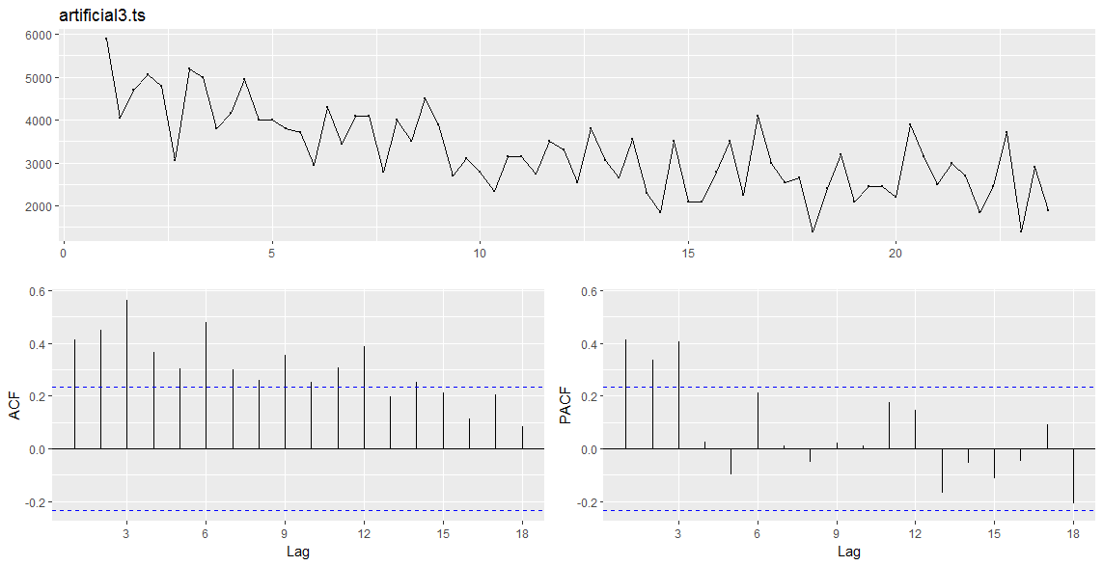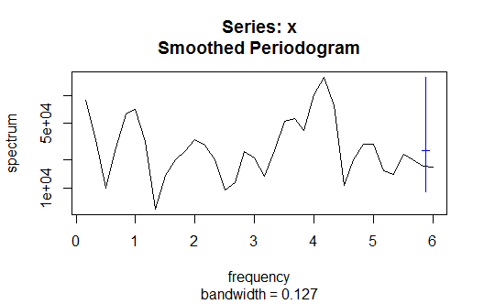

## D1

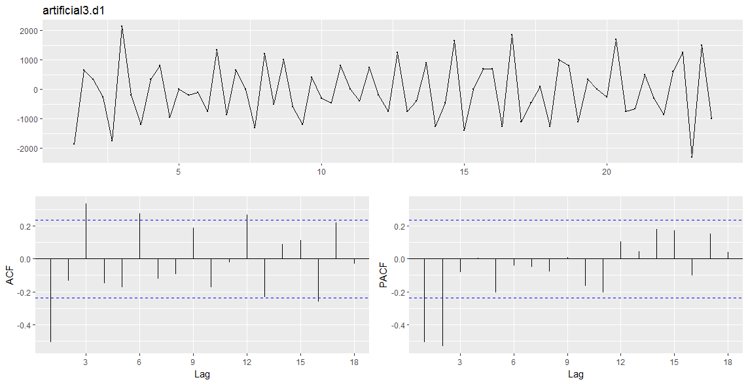

## D2

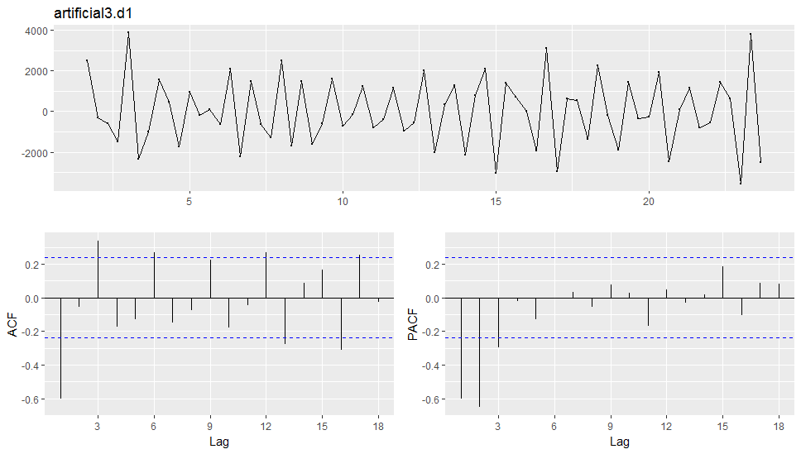

## SD1 FREQUENCY 3

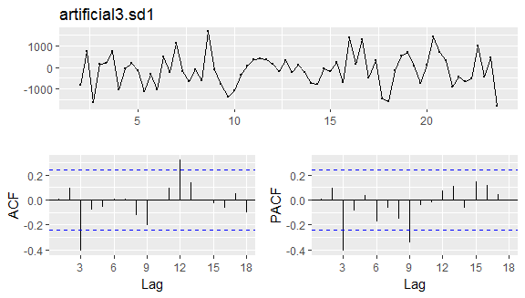

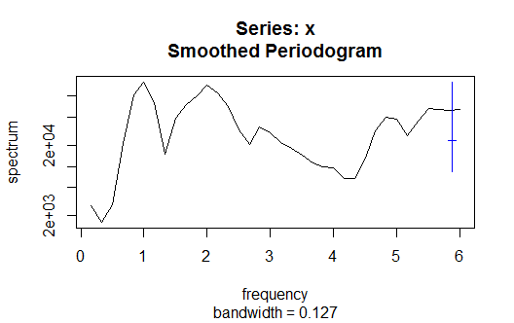

## SD2 Frequency 3

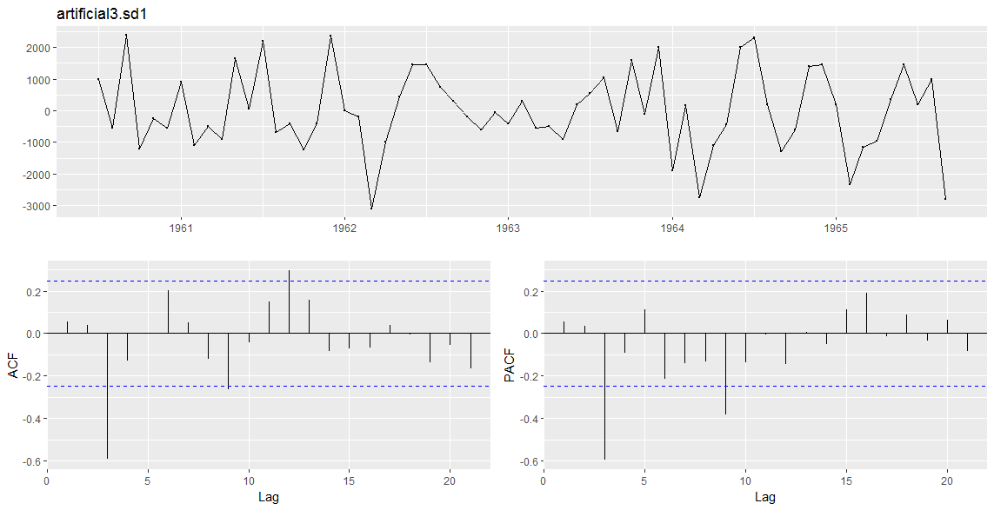

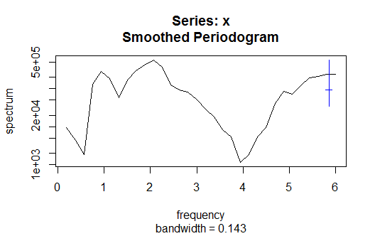

## SD1D1

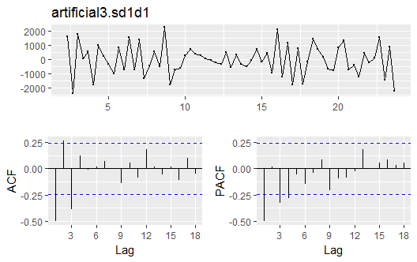

## SD1 FREQUENCY 12

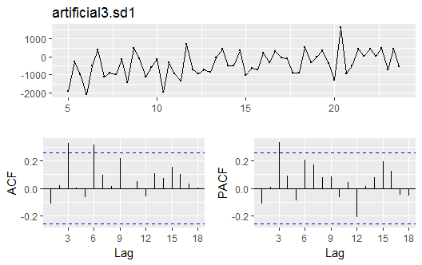

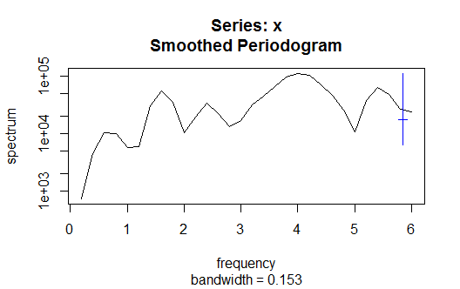

## SD1 Frequency 6

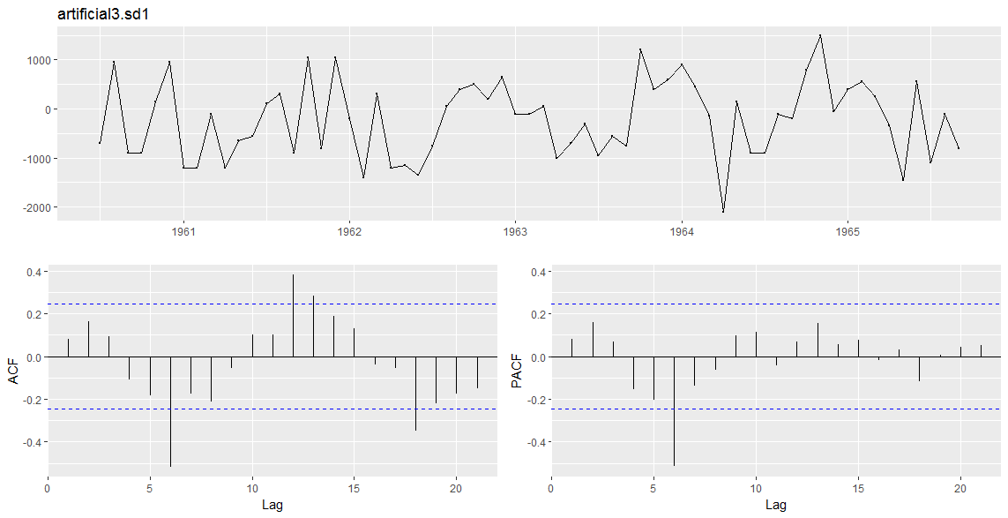

## SD2 Frequency 3 and 12

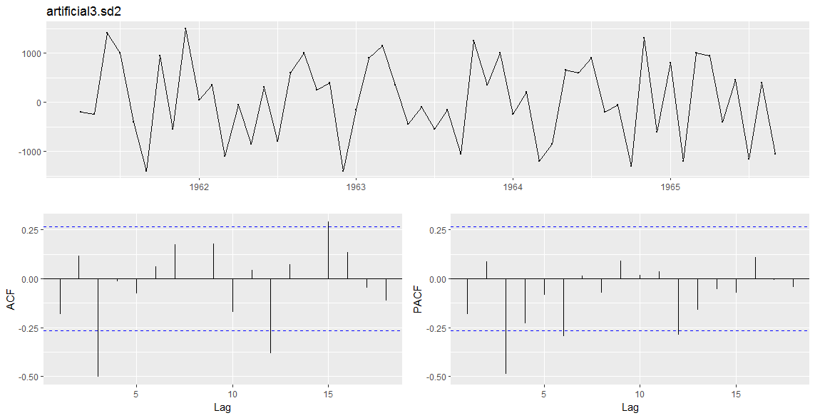

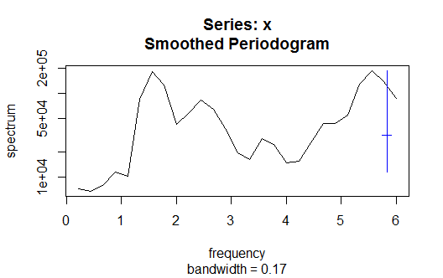

## HOLT WINTERS

### Frequency 12

ME RMSE MAE MPE MAPE MASE

Training set 66.11263 624.8389 502.2508 -0.4913866 17.79864 0.7573623

ACF1

Training set -0.2556995

### Frequency 3

ME RMSE MAE MPE MAPE MASE

Training set 92.7709 661.987 511.889 -1.603955 17.62342 0.8435623

ACF1

Training set 0.02734128